Module 03 Course Project [– Incorporating Loop Structures](https://learning.rasmussen.edu/webapps/assignment/uploadAssignment?content_id=_5418037_1&course_id=_60827_1&group_id=&mode=view)

Shaun Pritchard

Rasmussen College

COP1350c Section 01 C++ Programming

Mortoza Abdullah  
January 26, 2020

Module 03 Course Project [– Incorporating Loop Structures](https://learning.rasmussen.edu/webapps/assignment/uploadAssignment?content_id=_5418037_1&course_id=_60827_1&group_id=&mode=view)

**Contact manager program:**

Main menu  will use cin to gather user input to decide to access program object commands listed. Each menu item will consist of programmatic features to simulate CRUD operations for adding, storing, editing, reading, and deleting contacts as displayed in **Diagram 1:1**: using switch case to call function based on user input.

Menu List:

1. Add new contact
2. Show All contacts
3. Search for contact
4. Edit a contact
5. Delete the contact
6. Exit program

**The only functions that will be called with loop function are:**

* **delete_contact()**
* **edit_contact()**
* **display_contact**
* **show_all_contacts()**

show_contact(), create_contact(), Phone(), and save_contact() will not have loops to process.

**Main Console Menu**

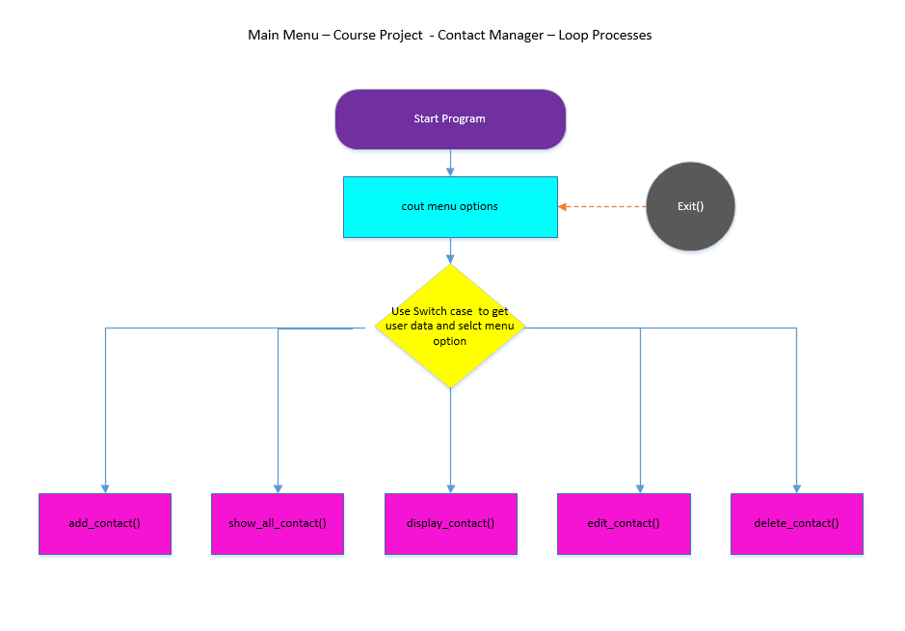

**Diagram 1:1**

**Delete Contact Function:**

The delete contacts function will use cin to get user input data

of the contacts phone number. It will then open the contact_database.dat using fstream to open and set temporary write data. using a while loop to read through the array of char based off contact array which is created from save-contact() to find the contact by phone number and remove the data.

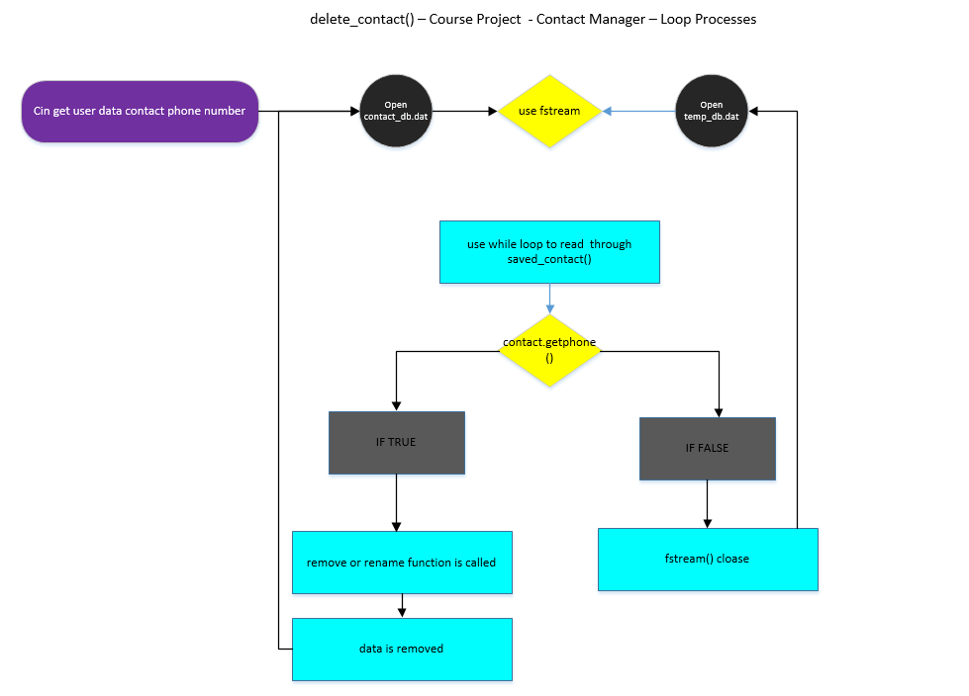

**Diagram 1:2**

**Edit Contact Function:**

The edit contact function will call for user input to enter the number for the contact the user is looking up. Then use fstream to open the contact_db.dat. Which will then iterate through a while loop and search through the contact array for the contact. Then match the sizes of int char with a nested if Loop. If Loop will be used to call phone number function to verify that it's a number being search in the array. if it is a number the user will be prompted to enter more user data which will use fstream to overwrite the data in the position of the contact array. Which will display all the user contact fields. If it is found to be false fstream will call close function an terminate the loop.

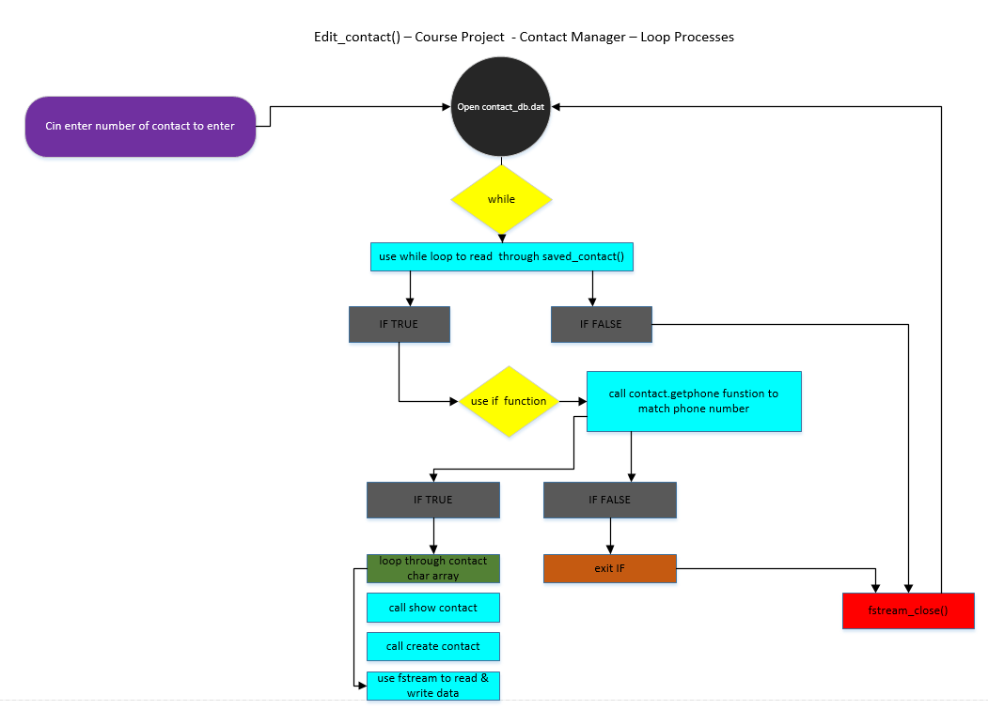

**Diagram 1:3**

**Display Contact Function:**

The display contacts function opens up the contact_db.dat then uses a while loop to read through save contacts object if the conditions are met we will use an IF function to call the get phone function and match the user input the phone number then look through the contact away if it is true and show the contact if it is false then it will close fstream and terminate the loop.

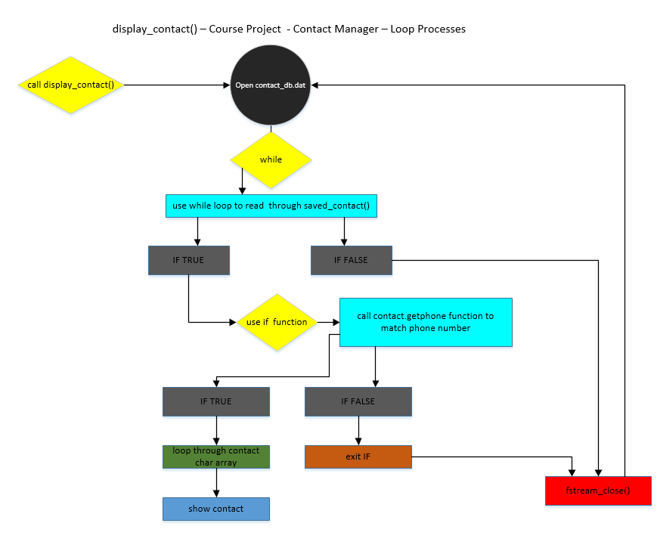

**Diagram 1:4**

**Show All Contact Function:**

The show all function uses a simple while loop using the display contacts function to open up the contact. The it uses a simple while loop to read through the save contacts class object array which will loop through and display all contacts in the console log.

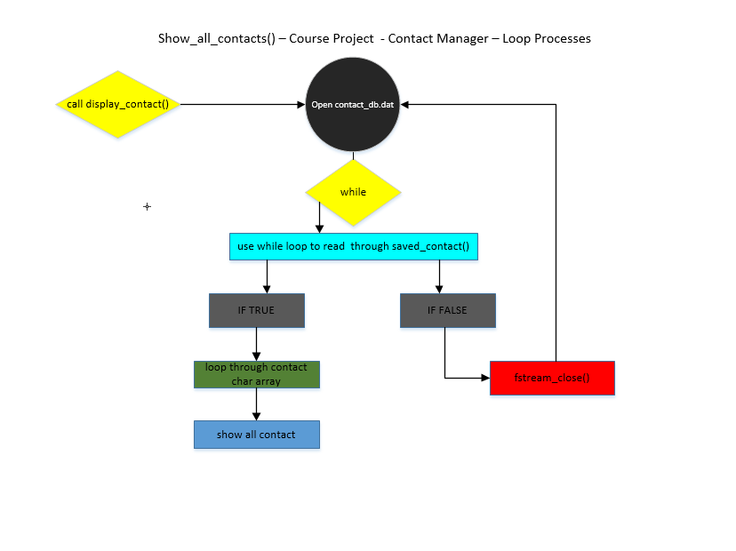

**Diagram 1:5**

This is an outline of the CMS Contact manger loop structures pseudo code.